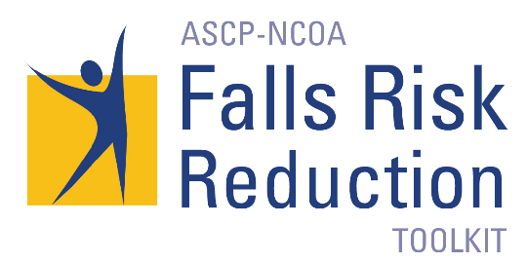
American Society of Consultant Pharmacists - ASCP
The ASCP-NCOA Falls Risk Reduction Toolkit: A Companion to CDC’s STEADI Tool Kit is designed to focus on falls risk factors in older adults identified to be at increased risk using screening tools, such as the Centers for Disease Control and Prevention’s (CDC) Stopping Elderly Accidents, Deaths & Injuries (STEADI) Toolkit. The toolkit guides the clinician through a more comprehensive assessment of falls risk inducing medications and medical conditions. Similar to STEADI, this toolkit conveys the importance of falls risk detection and management via an interprofessional approach. Given that medications and chronic conditions are often implicated as a risk factor for falling, the role of the pharmacist in falls risk reduction is emphasized.

The Collaborative Approach to Falls Prevention Workshop
Partnering with the Ohio Pharmacists Association (OPA), we are proud to bring this dynamic program to their Annual Meeting held on April 2, 2020 in Columbus, OH. Click here for course information and registration.

Checklist
This resource is the primary assessment tool in the Toolkit and serves as the basis for the recommendations by pharmacists and other clinicians using this Toolkit. Download »

Bibliography
This resource provides references to research and best practices related to getting to know your patient, medical conditions, medication assessment, falls risk inducing drugs (FRIDs) and alternatives to FRIDs. This bibliography, which will be updated annually, provides the evidence-base for the Checklist. Download »

Interprofessional and Older Adult/Caregiver Communication Templates
These templates are intended to convey pharmacist findings and recommendations to other clinicians and to serve as a follow-up communication with the older adult and/or caregiver. These templates can be customized for the clinician’s practice. Download »

Case Studies
Three case studies apply the use of the Checklist in reducing falls risk associated with medical conditions and medications. Download »

Authorization for Release of Medical Information
This form can be used by pharmacists and other clinicians to obtain additional medical information about their patients. It can also be used to obtain patient authorization to share personal health information. Download »

Community Resources and Referral
This section provides information about key clinical collaborators and community-based programs that pharmacists and other clinicians need to know about to develop a collaborative falls prevention service including cross-referrals. Download » Coming soon.

Consumer Resources
This section provides links to booklets, brochures and other handouts related to falls prevention and medications that can be given to older adults/caregivers for educational purposes. Download »

Discussion Forum
This discussion forum is a place for participants of the ASCP-NCOA Falls Risk Reduction Workshop to discuss the use of the ASCP-NCOA Falls Prevention Toolkit and topics of interest around the subject of falls prevention in older adults.

Background

How to Use the Toolkit

Source: https://www.ascp.com/page/fallstoolkit

