New Older Americans Act (OAA) Title III Summary Highlights:
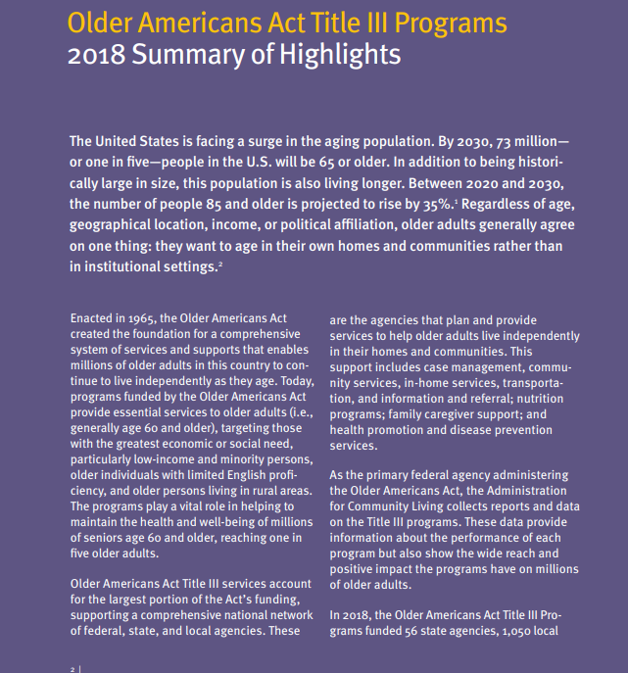

Overview of Older Americans Act Title III Programs: 2018 Summary of Highlights and Accomplishments (acl.gov)

