CDC – Stopping Elderly Accidents, Deaths & Injuries (STEADI)

Materials for Healthcare Providers
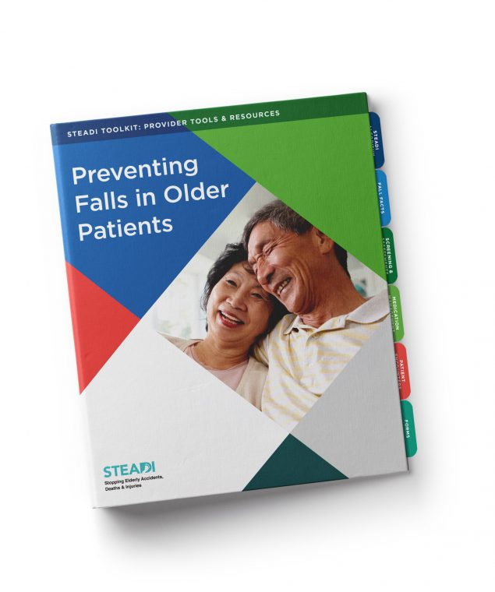
As a healthcare provider, you are already aware that falls are a serious threat to the health and well-being of your older patients. You play an important role in caring for older adults, and you can help reduce these devastating injuries.
The CDC’s STEADI initiative offers a coordinated approach to implementing the American and British Geriatrics Societies’ clinical practice guideline for fall prevention. STEADI consists of three core elements: Screen, Assess, and Intervene to reduce fall risk by giving older adults tailored interventions.
Educational materials specifically designed for older adults, their friends, and family are also included. See the list of materials included in the STEADI Toolkit.
Download materials below, or order hard copies from CDC-INFO on Demand.
- STEADI Basics
- Clinical Tools
- Functional Assessments
- Medication Review
- Fact Sheets
- Graphics
Algorithm for Fall Risk Screening, Assessment, and Intervention
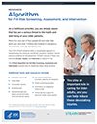
This tool walks healthcare providers through assessing a patient’s fall risk, educating patients, selecting interventions, and following up.

Download
- Algorithm for Fall Risk Screening, Assessment & Intervention pdf icon[552KB]
Preventing Falls in Older Patients: Provider Pocket Guide
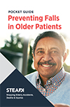
This small, easy-to-use tool walks healthcare providers through key points of fall prevention.

Download
- Preventing Falls in Older Patients: Provider Pocket Guide pdf icon[632KB]

Source: https://www.cdc.gov/steadi/materials.html

