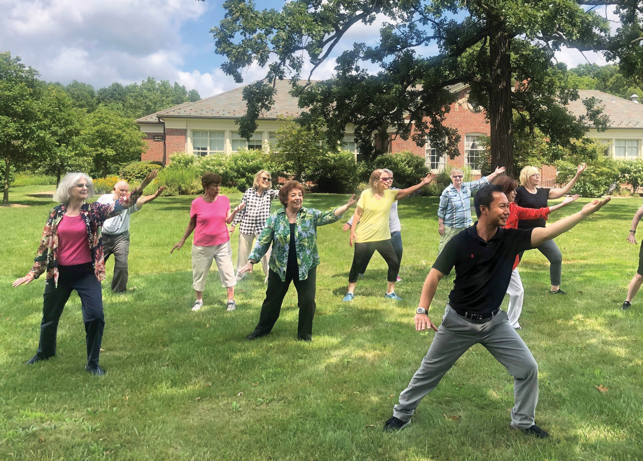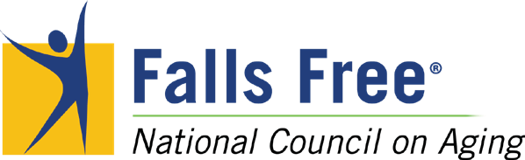

FALLS PREVENTION AWARENESS DAY

IM PACT REPORT

2019

THE IMPORTANCE OF FALLS PREVENTION

ne in four Americans
O

aged 65+ falls every year. Falls are the leading cause of fatal
and non-fatal injuries for older adults, and they are costly—both in dollars and in quality of life.
But falling is not an inevitable
part of aging.

Number of Individuals Reached

300Million
2019
2018
2017
2016
2015
2014
157Million
88 Million

Each year, on the first day of Fall, the National Council on Aging (NCOA) and its Falls Free® Initiative turns a spotlight on this critical health issue. Falls Prevention Awareness Day reaches millions
of older adults across the country with a simple message: You can take steps to prevent a fall.

99 Million
103 Million
2 Million

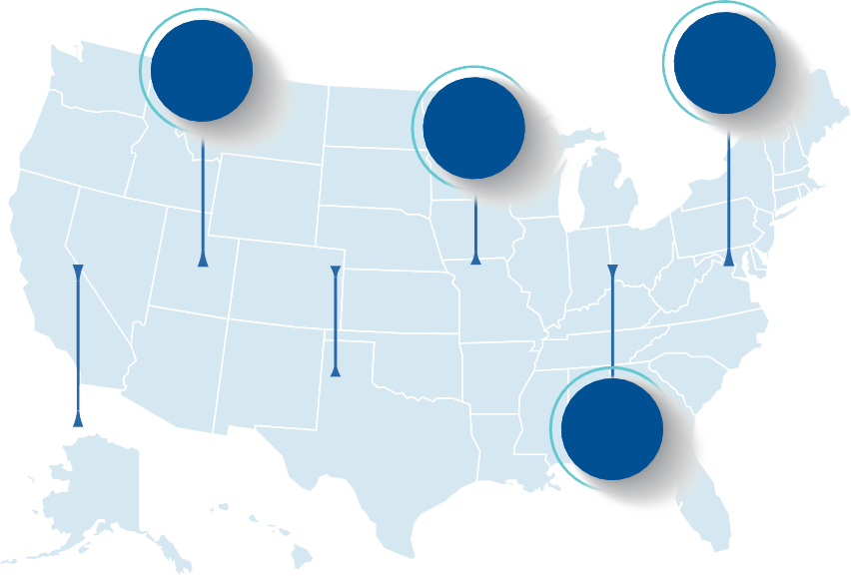Number of States Participating
49
44
49
2014
2016
2018
2015 2017 2019
49
42
48

NATIONAL OUTREACH

or Falls Prevention Awareness Day 2019, NCOA and its partners spread the message of falls prevention nationally and locally. On the national level, NCOA used traditional media, including print and radio, and social media to reach older adults, their caregivers, and the professionals who serve them. In the community,
F
state and local members of the Falls Free Initiative delivered the message in person by hosting education and awareness events for older adults, providing falls risk screenings, and advocating with lawmakers.

2019 National Reach

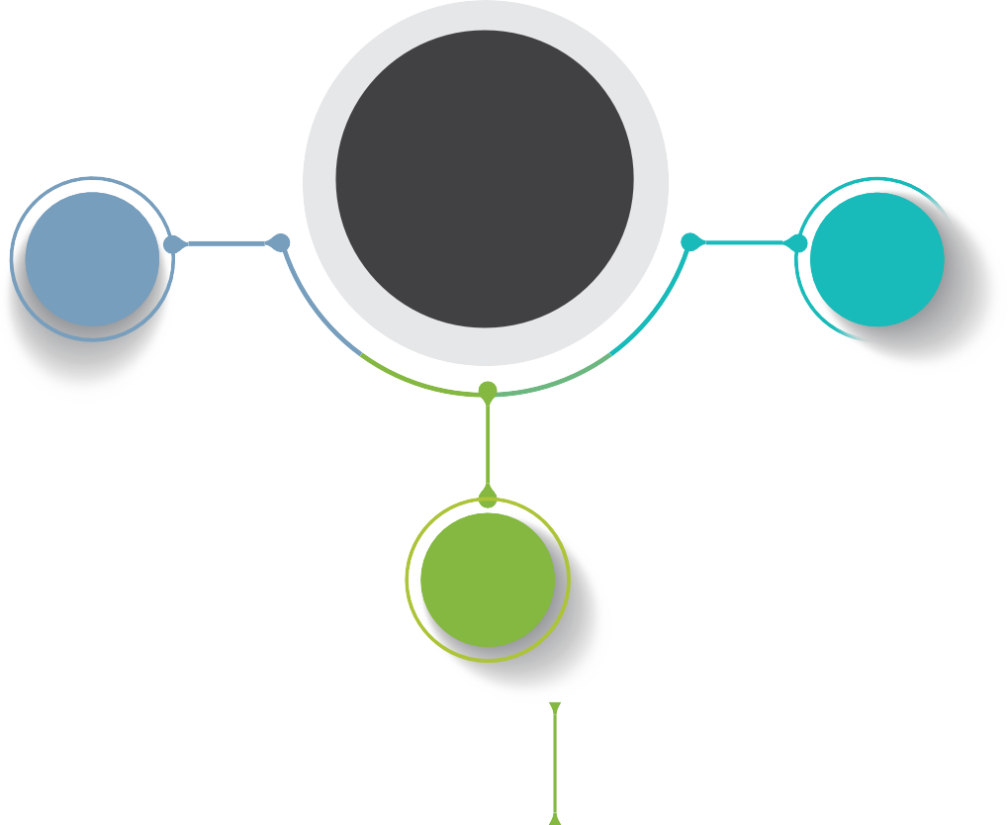TOTAL
300
million

SOCIAL MEDIA
13.5Million

GRASSROOTS
1.5 Million
Education
Falls Risk Screenings Advocacy

MEDIA
285

Million
Press Release Articles
Radio Tour

POLICY AND ADVOCACY

ffective falls prevention requires policy solutions, and NCOA and our partners brought those to lawmakers in September. Nineteen states obtained Governor’s proclamations in recognition of Falls Prevention Awareness Day. On Capitol Hill,
E
NCOA and our partners testified at a hearing of the Senate Special Committee on Aging titled Falls Prevention: National, State, and Local Solutions to Better Support Seniors. Several of NCOA’s recommendations were featured in the committee’s corresponding report, including organizing a coordinated federal effort to reduce falls, promoting early identification of falls risk factors, and improving Medicare to prevent falls. At NCOA’s urging, the U.S. Senate also passed resolution S.Res.327 designating September 23, 2019 as National Falls Prevention Awareness Day. The resolution was cosponsored by Sens. Susan Collins (R-ME) and Bob Casey (D-PA).

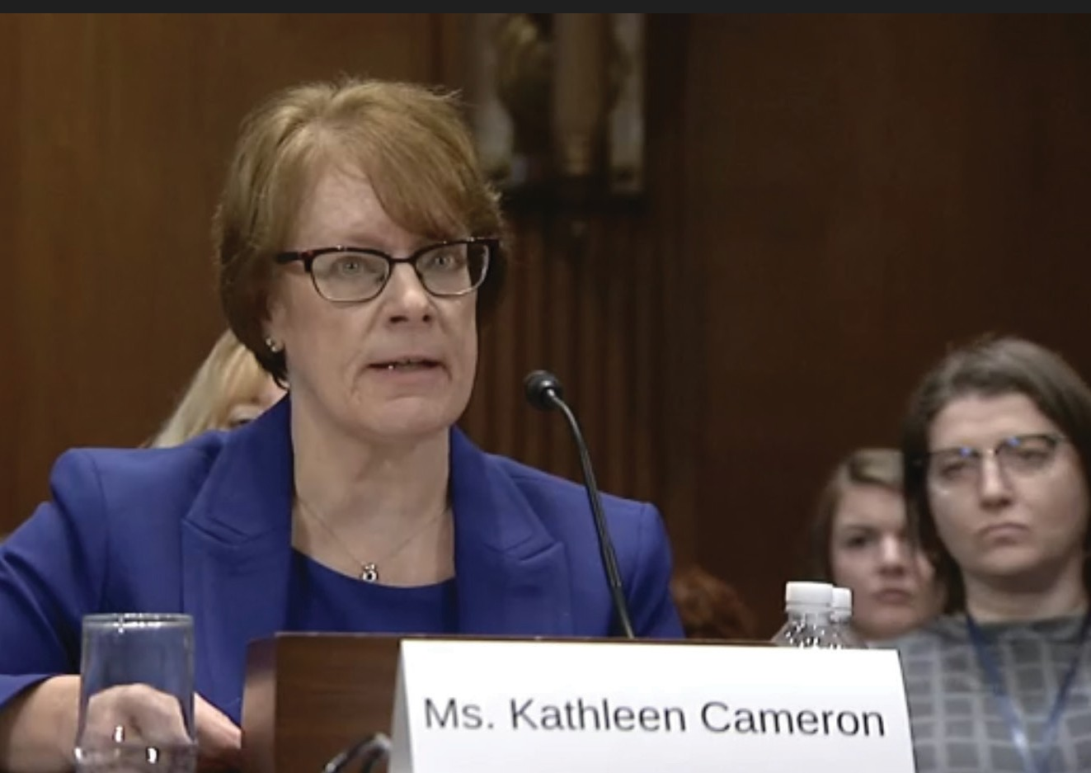

Kathleen Cameron, director of the NCOA National Falls Prevention Resource Center, testifies at a hearing of the Senate Special Committee on Aging, October 16, 2019.

GRASSROOTS EFFORTS
F

alls prevention is about awareness and action. A primary goal of Falls Prevention Awareness Day is to prompt older adults to take concrete steps to reduce their falls risk. In 2019, state and local partners accomplished this through health fairs and community events, in-person screenings for
falls risk factors, and advocacy efforts to engage state and local policymakers in addressing systemic challenges.

2019 Grassroots Reach

TOTAL
49 States
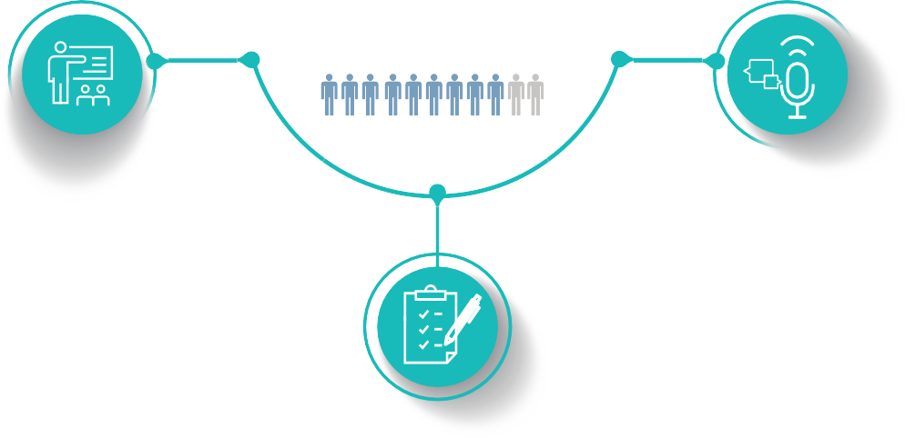
1.5 Million people

Education
100% of states reached
1.1 million older adults, caregivers, and professionals
Advocacy
56% of states engaged
500 public officials

Falls Risk Screenings
70% of states screened
12,000 older adults and caregivers

Falls Prevention Awareness Day 2019 was made possible in part by Centene Corporation. NCOA gratefully acknowledges our federal and national stakeholders, as well as the state and local Falls Prevention Coalitions for participating in Falls Prevention Awareness Day. We appreciate their year-round efforts to prevent falls and fall-related injuries among older adults.

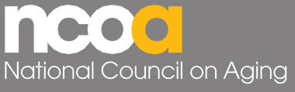SPONSORS
251 18th Street South, Suite 500 • Arlington, VA 22202
571-527-3900 • ncoa.org • @NCOAging
© 2020. National Council on Aging. All rights reserved.

ACKNOWLEDGEMENTS

- Allwell and Wellcare by Centene

NATIONAL STAKEHOLDERS

- Administration for Community Living
- American Association on Health and Disability
- American Occupational Therapy Association
- American Physical Therapy Association
- American Podiatric Medical Association
- American Society of Consultant Pharmacists
- Brain Injury Association of America
- Centers for Disease Control and Prevention, National Center for Injury Prevention and Control
- Evidence-Based Leadership Collaborative
- Genesis Rehab Services
- Meals on Wheels America
- National Alliance for Caregiving
- National Association of Area Agencies on Aging
- National Center for Healthy Housing
- National Indian Council on Aging
- National Osteoporosis Foundation
- National Senior Games Association
- Prevent Blindness
- Rebuilding Together
- Safe States Alliance
- University of Southern California Leonard Davis School of Gerontology, Fall Prevention Center of Excellence
- YMCA of the USA

Learn more at ncoa.org/FallsWeek.

