





Mindful Eating at the Holidays



With the holidays fast approaching and the stress level increasing, here are a few suggestions to help with holiday eating.

* Eat lunch or dinner before going to a holiday party, so you don’t overeat due to the fact that you are hungry.
* When at a party, take your time when enjoying the many treats that will be there, think about the taste, texture, and aroma of the food that you are enjoying.
* Have your guests serve themselves from the kitchen, sideboard, or service cart. If the food is not directly within your reach it will be easier not to keep adding things to your plate.
* Listen to your body’s cues for fullness to slow down or stop eating.
* When filling your plate make sure to have a variety of items- veggies, meat, side dishes, and bread.
* Have desserts and goodies last, this will give your body time to realize that it is full and you will eat a smaller amount but still enjoy the holiday treats.
* When at a party mingle and talk with guests. This will reduce the amount of time that you are mindlessly eating to entertain yourself and you will have a more enjoyable time at the party.
* The most important tip for the holidays is to relax and enjoy the holiday season with family and friends.

Nutrition Education Programs December 2020

Nutrition News

**Cranberry-Oatmeal Bars**

**Yield:** 24 servings (serving size: 1 square)

**Ingredients**

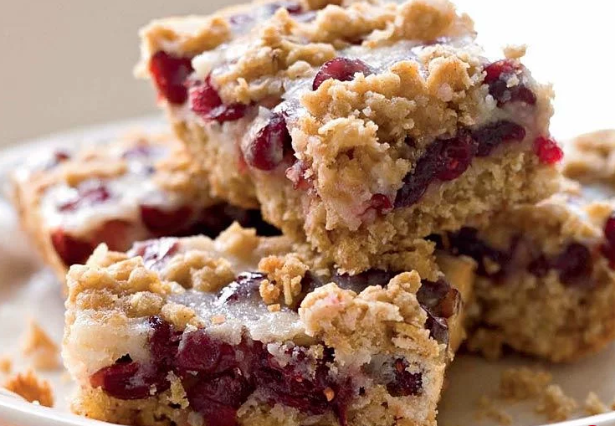

Crust:

4.5 ounces of all-purpose flour (about 1 cup)

1 cup quick-cooking oats

1/2 cup packed brown sugar

1/4 teaspoon salt

1/4 teaspoon baking soda

1/4 teaspoon ground cinnamon

6 tablespoons butter, melted

3 tablespoons orange juice

Cooking spray

Filling:

1 1/3 cups dried cranberries (about 6 ounces)

3/4 cup sour cream

1/2 cup granulated sugar

2 tablespoons all-purpose flour

1 teaspoon vanilla extract

1/2 teaspoon grated orange rind

1 large egg white, lightly beaten

**Directions**

**Step 1**

Preheat oven to 325°.

**Step 2**

To prepare crust, weigh or lightly spoon flour into a dry measuring cup; level with a knife. Combine flour and next 5 ingredients (through cinnamon) in a medium bowl, stirring well with a whisk. Drizzle butter and juice over flour mixture, stirring until moistened (mixture will be crumbly). Reserve 1/2 cup oat mixture. Press remaining oat mixture into the bottom of an 11 x 7-inch baking dish coated with cooking spray.

**Step 3**

To prepare filling, combine cranberries, sour cream, granulated sugar, and remaining ingredients in a medium bowl, stirring well. Spread cranberry mixture over prepared crust; sprinkle reserved oat mixture evenly over filling. Bake at 325° for 40 minutes or until edges are golden. Cool completely in pan on a wire rack.

**Step 4**

Cherry-Oatmeal Bars: Substitute dried cherries for the dried cranberries and lemon rind for the orange rind in filling.

https://www.myrecipes.com/recipe/cranberry-oatmeal-bars

**Southwest Idaho**

3630 Commercial Court

Meridian, ID 83642

(208) 336-9643

**Eastern Idaho**

555 South 1st Ave.

Pocatello, Id. 83204

(208) 233-8811

**North Central Idaho**

3331 10th St.

Lewiston, Id 83501

(208) 746-2288