Idaho’s

Information & Assistance/Options Counseling

Protocol Guide

(Alzheimer’s Disease Support Services

Program -

test phase)
This project was supported, in part by grant number 90ADSG0001 to the Idaho Commission on Aging from the U.S. Administration for Community Living (ACL), Department of Health and Human Services, Washington, D.C. 20201. Grantees undertaking projects with government sponsorship are encouraged to express freely their findings and conclusions. Points of view or opinions do not, therefore, necessarily represent official ACL policy.

Contents

I. Introduction

II. Service Definitions

III. Options Counseling A-E

IV. Study Protocols

V. Appendix

About this Guide

The purpose of this guide is to provide Area Agencies on Aging (AAA) staff who provide
Information & Assistance and Options Counseling services a helpful reference tool

Service Definitions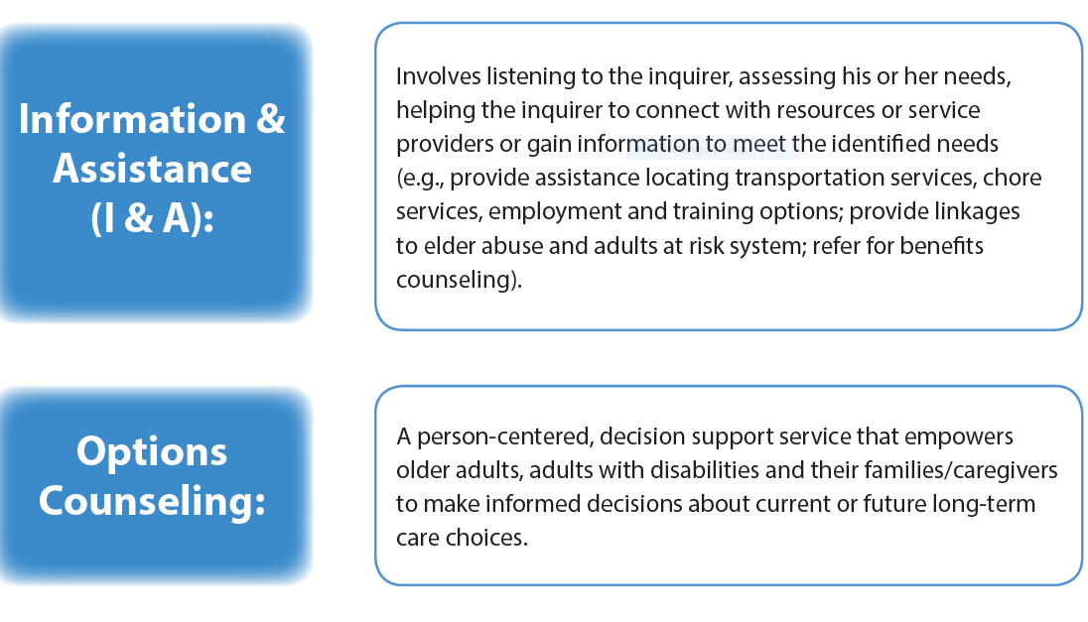

Connections between Information & Assistance (I & A) and Options Counseling
Options Counseling is an extension of I & A. The initial customer interaction in both I & A and Options Counseling begins with welcoming and engaging the customer and identifying the issue that brought them to the AAA. An exploration of community resources takes place in both discussions.
Options Counseling, unlike I & A, goes beyond educating customers about community services and supports. Options Counseling emerges, and becomes different from I & A, when decision-support takes place. Information is tailored to each customer based on their values and preferences, and then staff elicit the customer’s views on each of the options. Tools such as the Idaho Caregiver Assessment are employed during Options Counseling. This part of the conversation is a marker for decision-support. It is important to note that some individuals desire assistance to sort through the advantages and disadvantages of service options and narrow their options via decision-support. Others choose to forgo these conversations with AAA staff and choose to make decisions independently. A variety of circumstances may cause Options Counseling to be especially beneficial. Some of these include life changes such as:
• change in health status of caregiver or care receiver
• client is experiencing “caregiver burnout”
• becoming a caregiver for a loved one
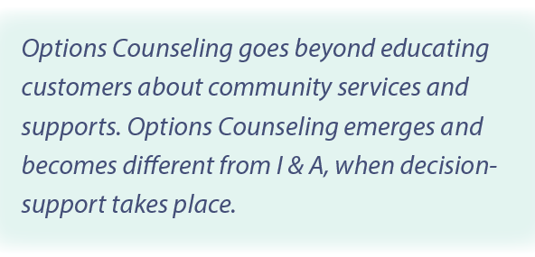

Option Counseling A-E

A. Welcome

As a professional at the AAA, staff provide the first impression that customers experience. Therefore, it is important to provide a welcoming reception, whether this takes place over the phone, in person, via email, or in another venue. Privacy and confidentiality are inter-connected. Customers tell us that their views of interaction with AAA staff are impacted by the privacy they are afforded during their contacts. Ways to ensure privacy include meeting in designated interview/conference rooms, or individual offices. Customers should be assured that the information is kept confidential; this is reinforced by providing privacy for customer interactions.

B. Discovery (See Idaho Caregiver Assessment Appendix A)
Discovery includes many things. It begins with learning why the individual reached out to the AAA; identifying the customer’s concerns and needs; and exploring what is or is not working with that person. Discovery includes identifying the individual’s strengths, values, and preferences, and the results they would like to see happen after their contact with the AAA. Discovery also includes identifying where the customer is in the decision-making process (see Caregiver Assessment).

C. Resource Options and Decision Support
Once a clear picture of the person’s situation has been obtained, and an understanding of what is important to them is ascertained, staff assist the customer by researching and identifying community resources that help meet the customer-identified needs. The primary goal of the decision-support process is to help the customer narrow the array of options so that choices made reflect those that best fit the customer’s needs. Therefore, it is essential that staff remain unbiased in their approach to these options and ensure that decisions made are congruent with what the customer needs and wants.

D. Action Plan
The Action Plan helps the customer move from identifying resource needs to specifying next steps. These next steps are predicated on the priority of the person, their desire to proceed, and the availability of services. During this conversation, it is important to discuss relevant informal supports and other available low-cost options. Customers should be assured that services identified in the Action Plan is not "set in stone” and that services can be considered on a trial basis. A written action plan can be offered to the customer as part of this step in the Options Counseling process.

E. Follow-up

The follow-up provides an opportunity to learn about the customer’s current situation and the outcome of previous conversations including whether changes or steps in the action plan occurred. Research conducted by Dr. Amy Flowers illustrates the importance of follow-up in customer satisfaction. Reminders in “tickler” files identifying specific follow-up activities at the end of a customer conversation are ways to prompt staff to ensure that follow-up occurs.

Options Counseling: Idaho Caregiver Assessment Protocols

A. I&A staff appointed to conduct Options Counseling and implement the caregiver assessment to caregivers for persons with dementia and other caregivers will be required to:

Training (Oct-Nov 2020):
- Complete I&A/Options Counseling Resource Guide: Caregivers for People with Dementia and Other Caregivers training on the ICOA website
  - Complete web-based survey at the end-of training. Survey results will be used to identify strengths, weaknesses and make improvements to the training
- Complete Motivational Interviewing: Engaging Caregivers, 3-part, 90-minute on-line training designed specifically for our AAA staff members by Jayne Josephsen, Boise State University School of Nursing. The training will be live via Zoom on Wednesday, 10/21, 10/28 and 11/4 from 1:00 - 2:30 MDT, invitation to follow.

Caregiver Assessment (Target 7 or more caregivers for PWD or other caregivers, AAA III will be required to reach 10-12):
- Each AAA will implement the person-centered Caregiver Assessment to 7 or more caregivers for persons with dementia or other caregivers, followed by:
  - Evaluation: I&A staff and/or option counselors will be interviewed by the BSU evaluation team to gather information on the process and outcomes of working with caregivers for persons with dementia or other caregivers. Results will be used to identify opportunities and challenges in providing assistance

Reporting Requirements due end of Feb 2021 and July 2021:
- Demographics will be collected from caregivers assessed (see Appendix B)
- Options Counseling Caregiver Assessment Log completed (see Appendix C)
- Participate with BSU evaluation team (Nov 2020 - Feb 2021):
  - By taking I&A Caregiving Training web-based, end-of -course survey
  - BSU Caregiver Assessment evaluation interview
- Attend quarterly conference calls

The information collected will be used to help create and sustain a dementia-capable Home and Community Based Services (HCBS) system that includes No Wrong Door (NWD) access for people with Alzheimer’s Disease and Related Dementias and their caregivers and facilitate process improvement.

Thank-you for all your time, effort, and support. Please contact me with any questions.

Lynn Fyanes
Lynn.Fyanes@aging.idaho.gov
ICOA Program Specialist
(208) 577-2852

Appendix
Appendix A Idaho Caregiver Assessment
Testers: Get Care is the management information system for the Idaho Commission on Aging (ICOA). The Area Agencies on Aging (AAAs) use the system to track clients and report services. If you are not a AAA and are helping ICOA test this assessment and determine if it will be useful to your agency, ignore the Get Care references for now, they are communications to the AAAs.
The information gathered helps the interviewer to understand the caregiver’s circumstances. The assessment is meant as an interview guide. As a result of the assessment process you and the caregiver can personalize suggestions, services, and supports. The assessment process may also help caregivers realize that they need other services, may help them determine how they will spend their respite breaks, and may help them understand they need decision support. Responses are confidential. Let caregivers know that information that is not personal may be gathered and combined with other caregiver responses to help determine if our agencies are reaching priority populations, offering the most needed services, or providing the most helpful referrals. For this assessment, “caregiver” refers to any relationship between a caregiver and a person of any age with special needs. Information about the care-recipient’s needs and desires will be collected in another assessment (Get Care) if needed.

Idaho Caregiver Assessment
1. Caregiver’s first/last name:

Caregiver’s address (this may not be needed after the document is tested and integrated with
Get Care):

2. Language preference (may not be needed when in Get Care):
3. Person you care for/care recipient’s first/last name:

What is your relationship to the person you care for? (circle response):
a. Spouse/partner
b. Parent/Step-Parent/In-law
c. Grandparent/other relative or non-relative of child
d. Daughter/Son/In-law
e. Sibling/In-law
f. Other Relative
g. Non-Relative/friend
h. Other (please specify)

4. Emergency contact for caregiver:

5. Were you aware of caregiver support resources prior to making this contact? Y or N

If yes, did you make use of caregiver support services in the past? Y or N

6. How did you hear about us (name of your agency)?
7. What prompted you to seek help now? (circle all that apply):

a. Care recipient condition changed
b. Caregiver health changed
c. Family circumstances changed
d. Family/friend/acquaintance referred
e. Professional/health care provider referred
f. Other referral: Please describe _______________

8. How would you describe your social support system? (READ LIST - check ONE that best describes)
[ ] excellent, includes willing family members and friends
[ ] good, includes family members and friends
[ ] fair, minimal support from family or friends
[ ] poor, no willing family members or friends

Who helps you provide care (may include family and friends at a distance who provide support)?

Name Relationship to Caregiver Assistance Provided
_______________________________________________________________________
______________________________________________________________________________________________________________________________________________

9. Are there others who could assist you (family, friends, neighbors, club members, volunteers from a religious institution)? Let’s list them:

10. How long have you been providing care for [care recipient name]? months_________
years __________
11. How often do you provide care to [care recipient’s name]?

a. Frequently throughout the day
b. Daily
c. Weekly
d. Monthly
e. Less than once per month

12. Do you live in the same home as the person for whom you care? Y or N

If YES, how well does the environment meet your needs as a caregiver?
If NO, how far do you travel to get to the care recipient’s home?

13. Are you also providing care to any other individuals? Y or N
If YES, who? (circle all that apply):

a. Friend/ neighbor
b. Spouse/partner
c. Sibling
d. Child/children
e. Child/children with a special need or disability under 60 years of age
f. Other

14. Are you, or the person for whom you care, a veteran? Y or N
15. Do you care for someone requiring supervision because of a memory and/or cognitive condition?
Y or N
16. What are your strengths as a caregiver?

17. What are the positive aspects of being a caregiver?
18. Do you have concerns about [the care recipient’s] safety? (e.g., falls, driving, cooking, wandering, alcohol or drug use, firearms, harmful to you or themselves) Y or N
If yes, please describe:

19. Are there issues that might cause you to consider asking someone to relieve you as caregiver, seek more care for [the care recipient], or transition into assisted living or a nursing home? (e.g., worsening dementia, falls, incontinence, your physical health, financial or emotional strain, etc.)
Y or N If yes, please describe:

20. Do you think you have a choice about being a caregiver or not? Y or N

Follow up discussion might include:
Yes (Are you doing alright? Can you continue? Is there anything you need to continue?)

No (Is there another family member or person to provide care? Would you consider moving your care receiver into a facility?)

21. How have you coped with challenges or roadblocks in the past?
22. Is there anyone you can call on short notice to fill-in for you as the caregiver? Y or N

If YES, does the person in #17 know she/he/they is/are the fill-in contact? Y or N

Do you have a plan of care for the fill-in caregiver to follow in your absence? Y or N

23. Do you have an emergency plan for emergency personnel to follow in your absence? Y or N
24. Has your health or/and emotional condition affected your ability to provide care? Y or N
25. During the last 12 months, have you been hospitalized anytime while being a caregiver? Y or N
26. Are you working or going to school/training outside of the home? Y or N

If Yes, has working outside the home affected your ability to provide care? Y or N

Has providing care impacted your ability to work outside the home or go to school/training? Y or N

27. Do you provide assistance to the care recipient with this activity? Circle all that apply. (If not you then who?):

a. Personal care tasks (includes bathing, dressing, transfers to bed/chair/car)
b. Homemaker chores (includes meals, laundry, shopping, mowing)
c. Transportation
d. Managing finances
e. Financial assistance (POA for finances)
f. Health care (includes medication management, wound care, handling equipment, POA for healthcare, understanding health insurance)
g. Care management (includes coordinating appointment, advocating for services, monitoring changes made by health care providers, therapists, etc)
h. Emotional and/or social support
i. Education or therapeutic plans
j. Legal matters
k. Other: Please describe

Modified Caregiver Strain Index
Here is a list of things that other caregivers have found to be difficult. Which apply to you? Your situation may be slightly different, but the item could still apply. | Yes, on a regular basis  (2 pts.) | Yes, Sometimes  (1 pt.) | No  (0 pt.)
My sleep is disturbed.
For example: person I care for wanders at night; needs
assistance: I can’t sleep
Caregiving is inconvenient.
For example: helping takes a lot of time; it is a long
drive over to help
Caregiving is a physical strain.
For example: lifting in or out of a chair/bed/toilet
Caregiving is confining.
For example: restricts my free time; I cannot go places I
enjoy
There have been family adjustments.
For example: helping has disrupted my routine; there is
no privacy; family arguments
There have been changes in personal plans.
For example: I could not go on vacation; I cannot
participate in activities that I enjoy
There have been other demands on my time.
For example: other family member needs me; work
There have been emotional adjustments.
For example: arguments with family about caregiving-
anger; sadness
Some behavior is upsetting.
For example: person cared for has memory issues-
outbursts
It is upsetting to find the person I care for has changed so much from his/her former self.
For example: he/she is a different person than he/she
used to be-unable to do things
There have been work adjustments.
For example: I have to take time off for caregiving
duties; adjusting schedules; unable to work
Caregiving is a financial strain.
For example: I use personal finances for caregiving-
unsure about future financial situation
I feel completely overwhelmed.
For example: I worry about the person I care for- I have
concerns for my future
Total Score

28. After our conversation today, what do you think are the most immediate issues or concerns that need to be addressed or that you need some assistance with? What things would you like us to address first?

29. If you could eliminate one thing from your daily or weekly routine to make life easier, what would that be?

30. What would you do more of if you had more time away from caring for [your care recipient]?

31. Would you like information, education and/or training about the following?
Circle all that apply. (Make sure you have a resource for each through resource database and/or community service contacts).

a. How to care for yourself while caring for others (social, physical/health, emotional/mental)
b. More information about care recipient’s disease/condition
c. How to engage family members or others to help (difficult conversations, family meetings, mediation)
d. Home safety and/or home modifications, assistive devices, or equipment
e. Legal and financial issues (Advanced Directive, POAs, living will, estate planning)
f. Long-term planning or care options (insurance, public programs, Medicaid, advance care planning, Medicare choices review with SHIBA and/or other benefits)
g. In-home support services (homemaker, chore, personal care, meals, shopping)
h. Respite care (in-home, out of home)
i. Choosing a long-term care facility (level of care needs, costs, research options)
j. Support Groups (caregiver, disease specific, on-line)
k. Caregiver Training Opportunities (conferences, classes, Powerful Tools for Caregivers)
l. Individual counseling options
m. On-line information and supports
n. Hands-on skills training for personal care tasks (bathing, transferring, toileting)
o. Telephone reassurance
p. Assistive technology (clock, adapted phone, home monitoring device)
q. Other. Please describe:

Tell us about yourself:
1. My age falls into the following group:  ____ Younger than age 30  ____ 31-40  ____ 41-50  ____ 51-60  ____ 61-70  ____ 71 years and older | 2. I am:  ____ Female  ____ Male
3. I am a (select the ONE that best describes you):  ____ Person with Alzheimer’s or related dementia  ____ Caregiver for a person with memory loss  ____ Caregiver | 4. I am caregiving for:  ____ Spouse or partner  ____ Parent  ____ Child  ____ Myself  ____ Other Caregiver
5. I live in a:  ____ Urban area (community of more than 50,000 people)  ____ Rural area | 6. I have:  ____ Served in the military  ____ Not served in the military
7. I would describe myself as:  ____ Hispanic or Latino  ____ Not Hispanic or Latino | 8. My race is:  ____ American Indian or Alaskan Native  ____ Asian or Asian American  ____Black or African American  ____ Native Hawaiian or other Pacific  Islander  ____ White
9. I would consider myself:  ____ Minority  ____ Not Minority | 10. If the person you are caring for has dementia, what is their living arrangement:  ____ Lives alone, has an identified  caregiver  ____ Live alone, no identified caregiver  ____ Does not live alone
11. How did you hear about AAA services:
____ Area for Aging Website ____ Community service provider
____ Healthcare provider ____ Advertisement
____ Employer or colleague ____ Family member or friend
____ Other, please describe:
Appendix B Caregiver Assessment Participant Demographics

Your participation in the evaluation is voluntary and confidential. You may skip any question(s) you do not feel comfortable answering. If you have questions, contact your class leaders or Sarah Toevs, Director, Study of Aging, 1910 University Drive, Boise ID 83725-1835, 208-426-2452 or the Institutional Review Board at Boise State University, Office of Research Administration, 1910 University Drive, Boise, ID 83725-1135 or (208) 426-1574. Completion of this survey implies your consent to participate. Thank You!

This project was supported, in part by grant number 90ADSG0001 to the Idaho Commission on Aging from the U.S. Administration for Community Living (ACL), Department of Health and Human Services, Washington, D.C. 20201. Grantees undertaking projects with government sponsorship are encouraged to express freely their findings and conclusions. Points of view or opinions do not, therefore, necessarily represent official ACL policy.

Appendix C
Options Counseling Caregiver Assessment Log
Agency Name: | #
How many I&A staff completed ICOA Website Information and Assistance--Caregiving, Caregiving for People with Dementia, and Assistance for People with Dementia training
Hours spent on ICOA Caregiving Website training
How many caregivers were assessed?
Caregivers for persons with dementia
Other Caregivers
Hours spent completing each caregiver assessment

This project was supported, in part by grant number 90ADSG0001 to the Idaho Commission on Aging from the U.S. Administration for Community Living (ACL), Department of Health and Human Services, Washington, D.C. 20201. Grantees undertaking projects with government sponsorship are encouraged to express freely their findings and conclusions. Points of view or opinions do not, therefore, necessarily represent official ACL policy.

