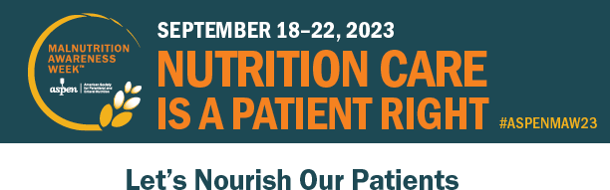

September 18 | September 19 | September 20 | September 21 | September 22
12:00-1:30 PM ET | 12:00-1:30 PM ET | 12:00-1:15 PM ET | 12:00-1:15 PM ET | 12:00-1:00 PM ET
Malnutrition in the Patient with Obesity: How to Address the Under Recognition | Is This Malnutrition? How to Approach Common Diagnostic Challenges | Pediatric Malnutrition Diagnosis and Provider Engagement | Addiction: The New Skeleton in the Hospital Closet | Malnutrition and Transitions of Care Between Health Care Settings
CE Credit: 1.5 hours | CE Credit: 1.5 hours | CE Credit: 1.25 hours | CE Credit: 1.25 hours | CE Credit: 1.0 hour

Visit nutritioncare.org/MAW to register for the webinars and access complimentary practice tools, videos, podcasts, and other resources addressing malnutrition.
The Idaho Commission on Aging is an official ambassador for ASPEN Malnutrition Awareness WeekTM.

The Idaho Commission on Aging members can use the code [MAW Ambassador Code] to complimentary registration to the webinars.

Participants may be eligible to claim CE credits for the webinars. ASPEN, the American Society for Parenteral and Enteral Nutrition, is accredited to provide medical, pharmacy, nursing, and dietetic credits. Webinar schedule and topics subject to change.

Malnutrition Awareness WeekTM is a trademark of the American Society for Parenteral and Enteral Nutrition (ASPEN).

