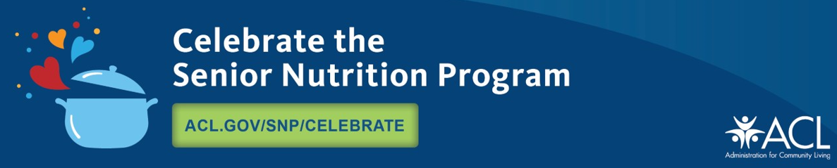
Let`s celebrate the Anniversary of the Senior Nutrition Program
Since 1972, the national Senior Nutrition Program has supported nutrition services for older adults across the country. Funded by the Older Americans Act (OAA), local programs serve as hubs where people 60+ find healthy meals and other vital services that strengthen social connections and promote well-being.

Each March, the Administration for Community Living (ACL) celebrates the program's anniversary and the many accomplishments of the national and local programs. They promote how nutrition services help people stay independent as they age, and they highlight critical senior nutrition issues. The Idaho Commission on Aging (ICOA) promotes its anniversary by celebrating the program's rich history and tremendous value across the nation with Area Agencies on Aging and meal providers.

Our senior nutrition program provides nutrition services for older adults in our community, including home-delivered meals and meals served in group settings like senior centers.
https://aging.idaho.gov/event/free-malnutrition-webinar/
Just this past Federal Fiscal Year, our senior nutrition program provided 1,104,721 home-delivered meals and congregate meals in our community. But our program goes beyond food – Our services also offer a vital link to other home and community-based supports that increase socialization, independence, and well-being. ICOA and their six contracted Area Agencies on Aging connect older adults with other community supports like Fit and Fall prevention classes, caregivers, transportation, adult protective services, Alzheimer`s, homemaker, and chore services and more.

ACL funds senior nutrition services, including home-delivered and congregate meals. For more resources follow ACL on Facebook and join the conversation via Celebrate the Senior Nutrition Program | ACL Administration for Community Living

Please join the Idaho Commission on Aging in spreading awareness about malnutrition and food insecurity and help to reduce hunger. Encourage the elders to congregate at a senior center at least weekly for healthy benefits for mind and body!

For more information on Congregate Meal Sites and Home-Delivered Meals, please contact your local Area Agency on Aging.

Please join our free educational webinars on Malnutrition March 19th at 10:00am Mountain Time and on Connection in Every Bite March 21st at 2:30pm Mountain Time. For additional nutrition information please visit the ICOA website and follow us on Twitter and Facebook.

Visit here to see how the healthcare system benefits if seniors eat a nutritious meal at a congregate meal site.

